**Panja, Kumara Satya Gopal**

**Assignment -1**

**Class ID: 32**

**UMKC ID: 16222771**

I created "BigData-Assignements" repository and cloned it into local. And created two directories (Source, Documentation) and sync it into remote Github. Created 15 issues and 3 iterations. Each iteration contains 5 issues.

**Board:**

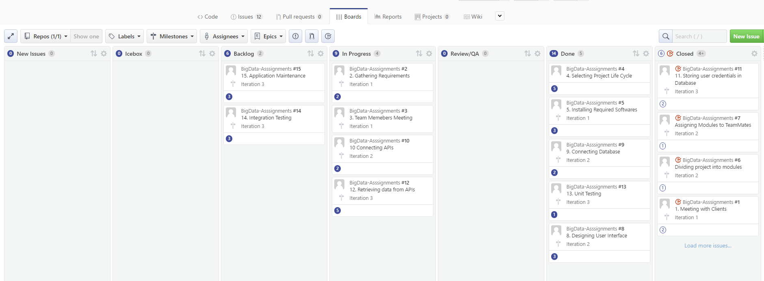

**Iteration1-Graph:**

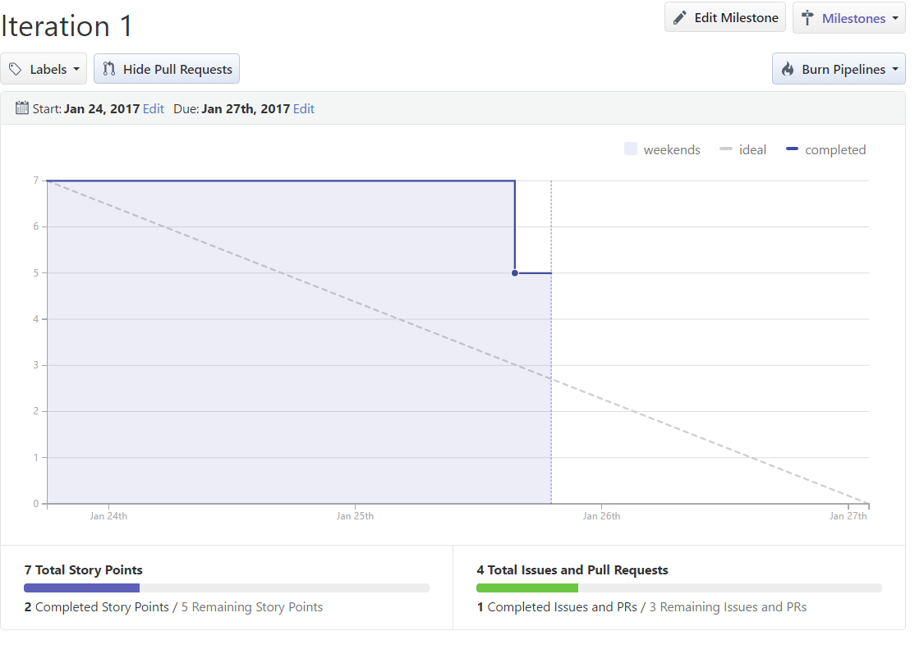

**Iteration1-Issues:**

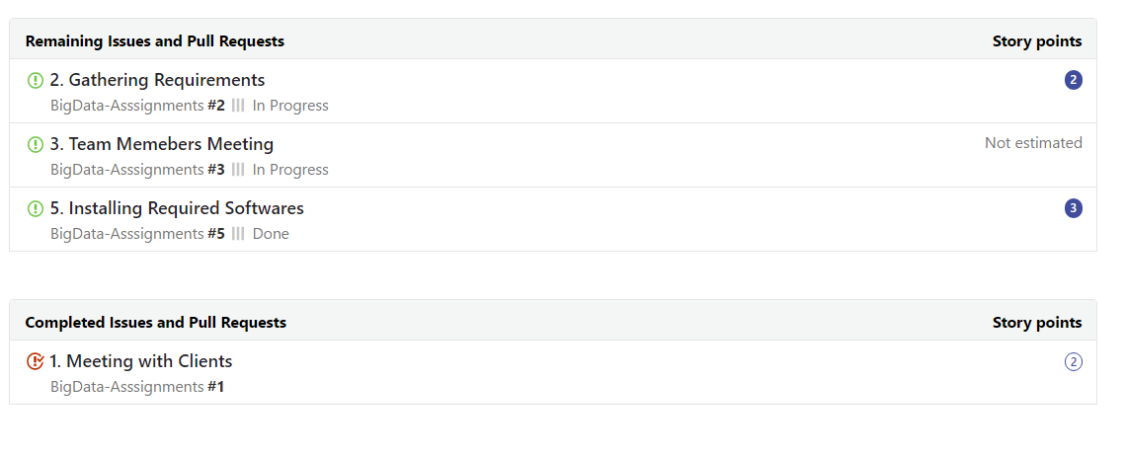

**Iteration2-Graph:**

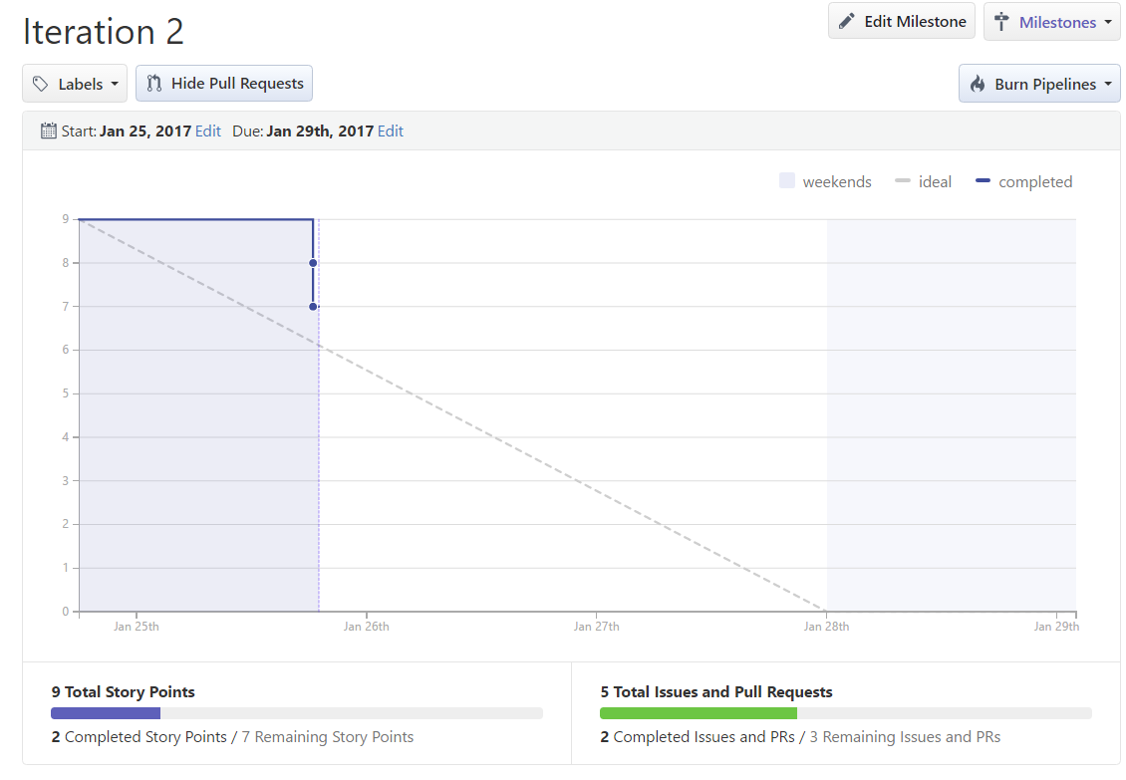

**Iteration2 – Issues:**

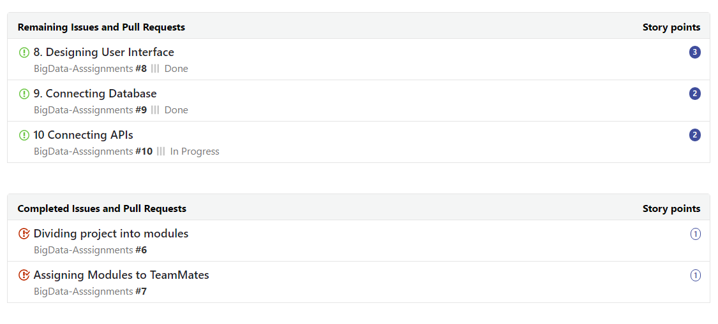

**Iteration3-Graph:**

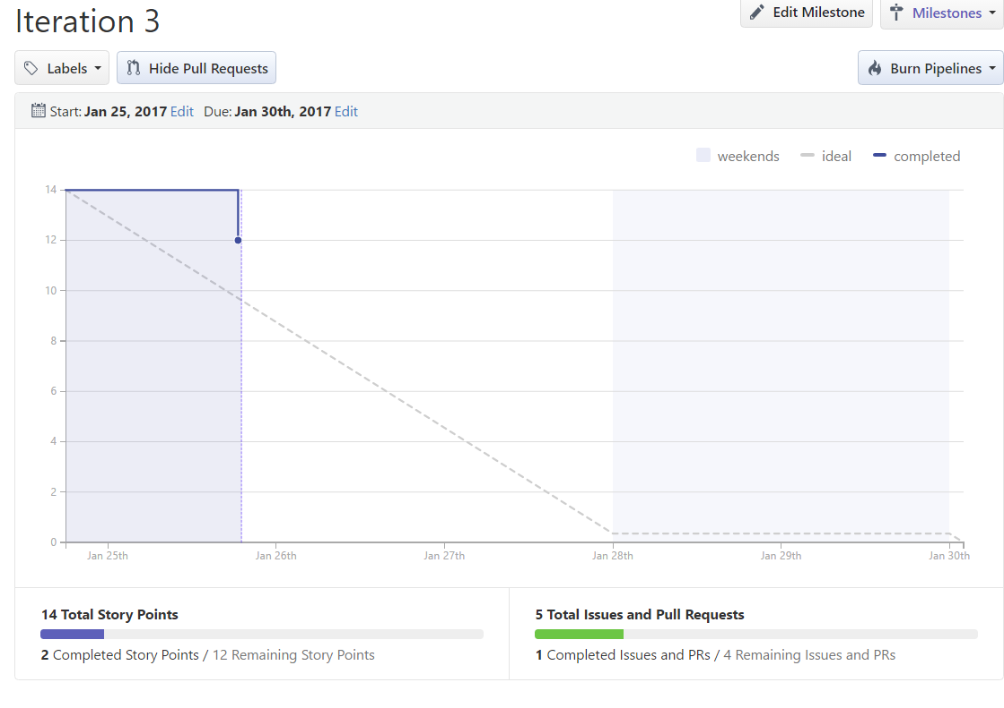

**Iteration3 – Issues:**

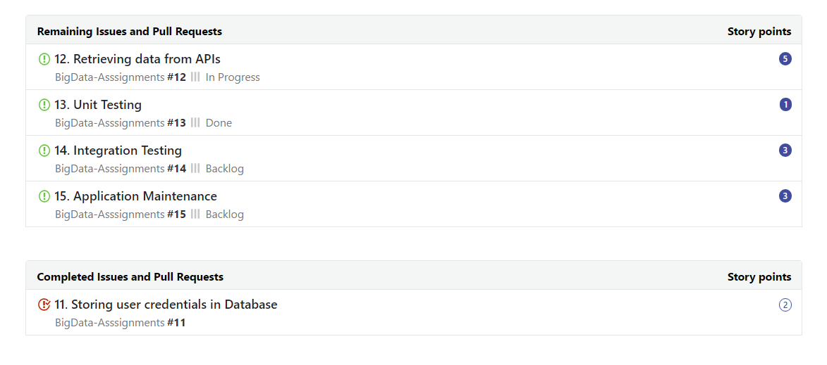

**OddManOut Problem:**

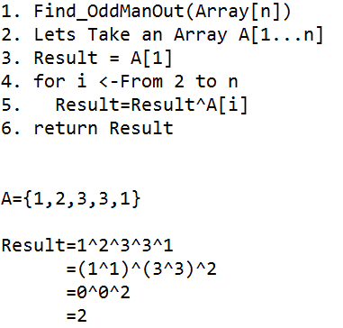

**Chimpanzee Monitoring System:**

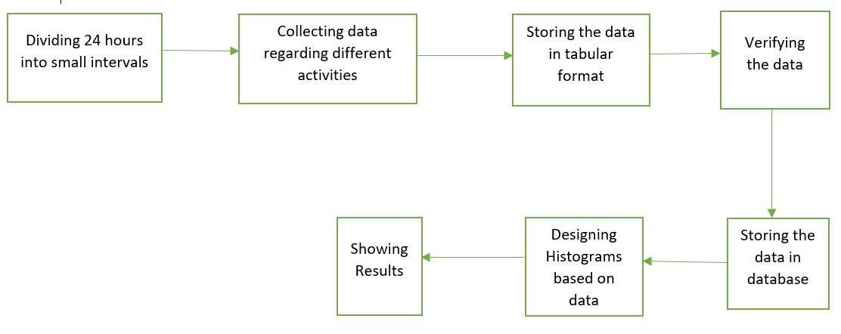

**Architecture Diagram:**